**PHASE 5**

**PRODUCT SALES ANALYSIS**

**Below, I outline the project's objectives, the design thinking process, and the development phases for a product sales analysis project.**

1. **Objectives:**

* Sales Forecasting: Predict future sales trends accurately to inform inventory management and production planning.
* Customer Segmentation: Identify and segment customer groups based on behavior, preferences, and purchase history to personalize marketing strategies.
* Competitive Analysis: Analyze the competitive landscape to understand market positioning and identify opportunities for differentiation.
* Inventory Optimization: Ensure optimal inventory levels to avoid overstocking or stockouts, reducing carrying costs.

2. **Design Thinking Process**:

* Empathize: Understand the needs and pain points of stakeholders, such as sales and marketing teams, customers, and inventory managers. Conduct interviews, surveys, and observe their processes.
* Define: Define the specific problem areas and objectives of the sales analysis project. Consider what data and insights are needed to address these issues effectively.
* Ideate: Brainstorm creative solutions for data collection, analysis, and visualization. Consider the innovative technologies, methodologies, and tools that can be applied.

3. **Development Phases:**

* Data Collection: Gather sales data from various sources, including point-of-sale systems, e-commerce platforms, and customer feedback. Ensure data quality and consistency.
* Data Preprocessing: Clean and prepare the data, handling missing values, outliers, and standardizing formats.
* Dashboard and Visualization: Develop interactive dashboards and visualizations to present the analysis results in a user-friendly way. Tools like IBM Cognos,Tableau, Power BI, or custom web applications can be used.
* Deployment: Deploy the final product within your organization, ensuring that stakeholders can access and utilize the sales analysis tools.
* Maintenance and Iteration: Continuously monitor the project's performance, gather user feedback, and make improvements or updates as needed to keep the analysis relevant and effective.
* Certainly, I can provide an overview of a product sales analysis with a focus on the analysis objectives, data collection process, data visualization using IBM Cognos, and derived actionable insights.

1. **Analysis Objectives**:

* Sales Forecasting: Predict future sales trends accurately to optimize inventory management and production planning.
* Customer Segmentation: Identify and segment customers based on their behavior and preferences to tailor marketing and sales strategies.
* Pricing Strategy: Determine effective pricing strategies that maximize profitability while remaining competitive.

1. **Data Collection Process**

Data collection involves regular extraction and integration of data from these sources into a centralized data warehouse. ETL (Extract, Transform, Load) processes are used to clean and standardize the data.

1. **Data Visualization using IBM Cognos**:

IBM Cognos is a powerful tool for data visualization and reporting. In this analysis, IBM Cognos is used to create interactive dashboards and visualizations, including:

* Sales Trend Analysis: Line charts and time series visualizations to track historical and forecasted sales trends over time, identifying seasonality and trends.
* Customer Segmentation: Cluster analysis results visualized using pie charts, bar graphs, or bubble charts, illustrating the distribution of customers across segments.
* Pricing Analysis: Scatter plots and heat maps visualizing the relationship between pricing strategies and sales volumes, helping to identify optimal price points.
* Marketing Campaign Effectiveness: Bar charts and funnel charts showing the impact of marketing campaigns on customer acquisition and sales conversion rates.

1. **Derived Actionable Insights**:

Based on the analysis and visualizations, actionable insights are derived:

* Sales Forecasting:Accurate sales forecasts indicate when to adjust inventory levels.
* Customer Segmentation: Segments can guide personalized marketing strategies. High-value customers may receive exclusive offers, while cost-conscious segments may benefit from discounts.
* Pricing Strategy: Visualizations help identify the pricing strategies that maximize revenue and profit margins.
* Marketing Strategy:Insights from campaign analysis show which marketing efforts are most effective, helping allocate resources more efficiently.
* Inventory Management: Inventory level visualizations provide a clear overview, ensuring efficient use of resources and minimizing carrying costs.

The insights derived from this analysis enable data-driven decision-making, better customer experiences, reduced costs, and increased sales and profitability.

* Insights from product sales analysis play a pivotal role in guiding inventory management and marketing strategies. Here's how these insights can influence these critical areas of business.

1.**Inventory Management**:

* Demand Forecasting: Sales analysis provides historical data and predictive insights, which can help in forecasting future demand more accurately.
* Seasonal and Cyclical Patterns: Understanding sales trends, seasonality, and cyclical patterns allows inventory managers to plan for peak seasons and optimize stock levels during off-peak periods.
* Obsolete Products: Sales analysis can highlight products that are not performing well. Inventory managers can use this information to identify slow-moving items.

2.**Marketing Strategies**:

* Customer Segmentation: Sales analysis helps identify different customer segments based on behavior and preferences.
* Promotion Effectiveness: Analyzing the impact of marketing campaigns and promotions on sales can reveal what works and doesn't.
* Product Performance: Insights into product performance can guide marketing efforts. High-performing products might require less marketing support, while underperforming products may benefit from marketing interventions.
* Pricing Strategies: Pricing insights derived from sales analysis can guide pricing strategies. Businesses can adjust prices based on customer responsiveness and market conditions, maximizing profitability.
* Product Development: Analysis of customer feedback and sales data can inform product development decisions. Identifying popular features or areas for improvement can guide product development efforts.
* Inventory Promotion: If there is excess inventory, marketing strategies can be designed to clear it, such as running clearance sales, bundling slow-moving products with popular ones, or creating limited-time offers.
* Visualization using IBM Cognos:

Visualization insights for product sales analysis dataset using python. These are the outputs for the given dataset.

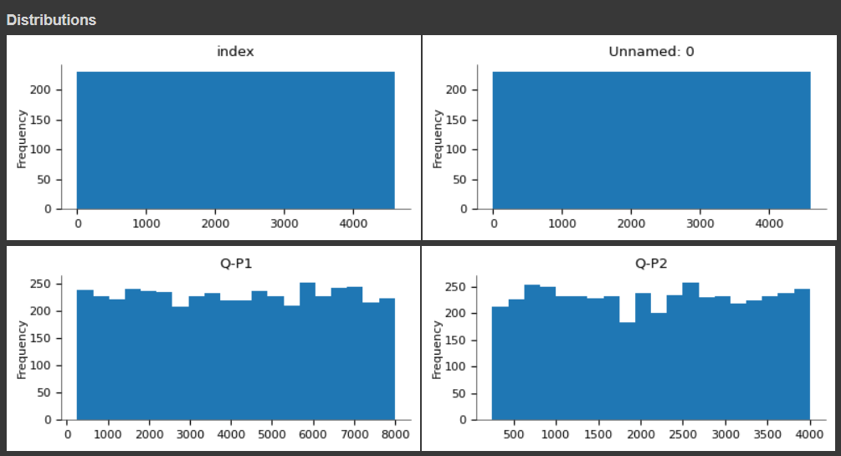

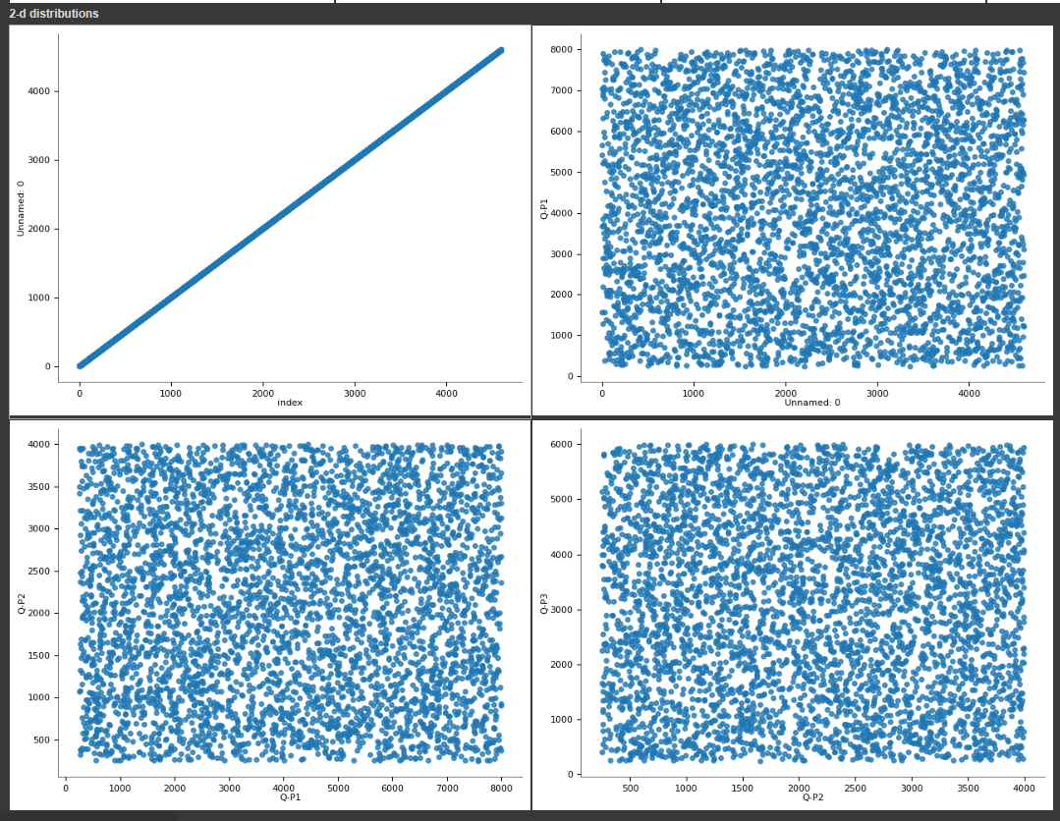

1.**Peak Sales Periods:**

To calculate the peak sales product in dataset using Python, we need to analyze a dataset that information about products and their sales.

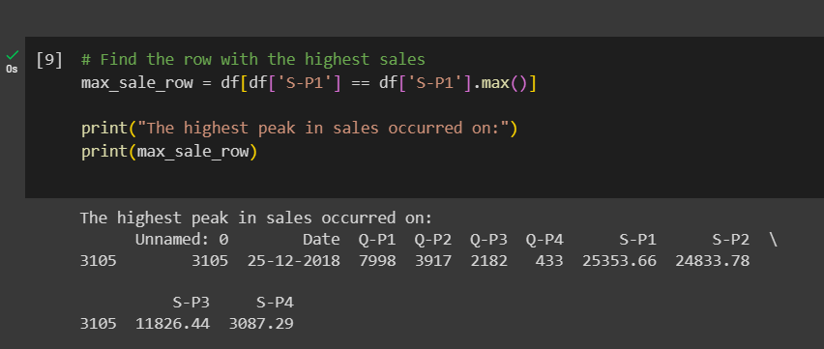

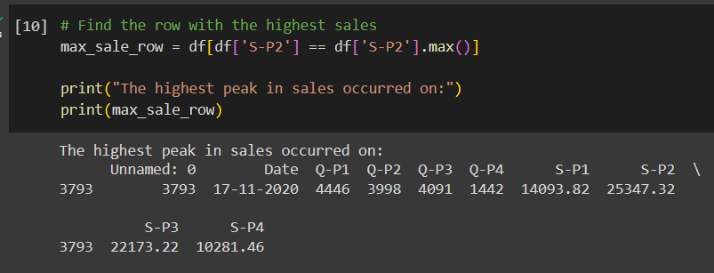

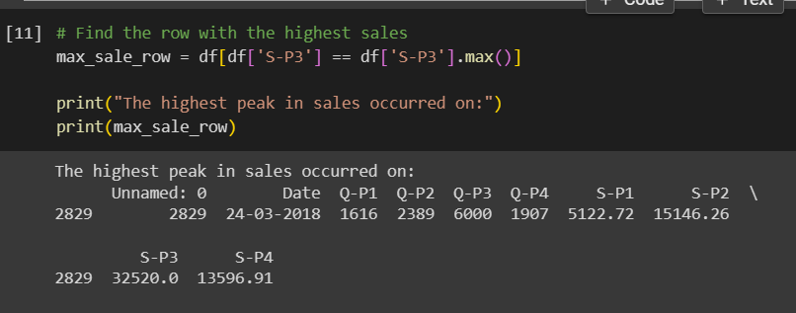

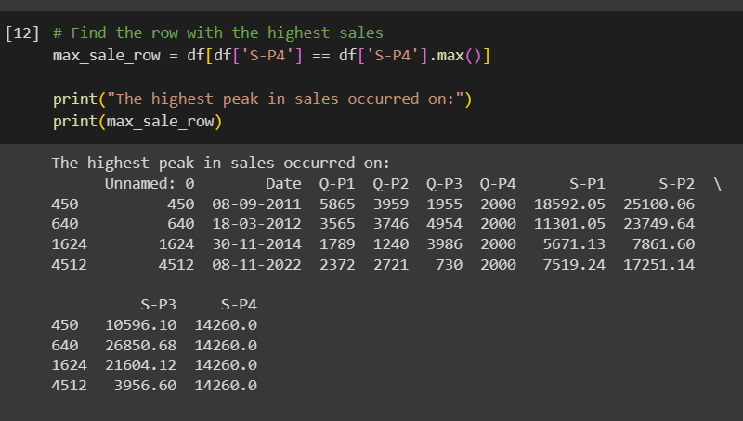

2.**Highest Sales:**

Using Python programming we calculating the Highest peak in a product sales dataset. We need to analyze the dataset and identify the points with the highest sales.

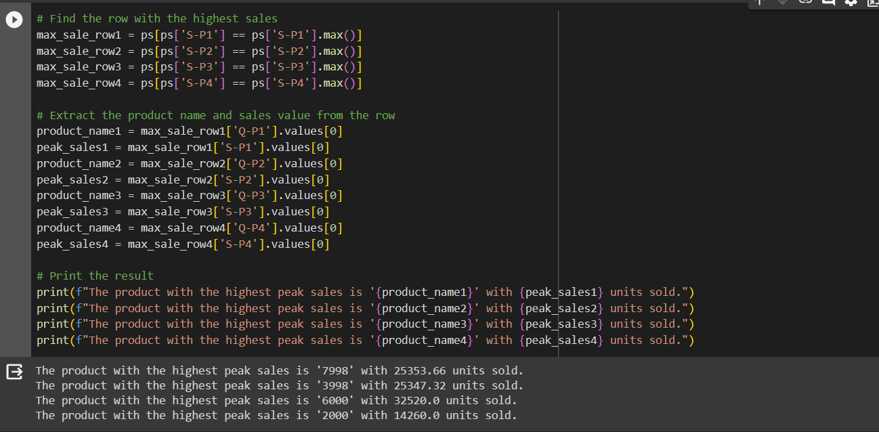

3.**Customer Preferences:**

Customer preferences can be determined in various ways, depending on the nature of the dataset. We will calculate customer preferences based on the number of purchases with specific products in a dataset using python.

